Week 2 Notes - Conditionals and Project

Thanks for coming to class today! Please read these notes to review what we learned, along with some helpful examples!
Note: We highly encourage asking questions! If you haven’t done this yet, please review Week 1 Notes that we sent out last week 🙂

“Special Characters” (Python Escape Codes)
- There are “special characters” called Escape Codes that are designated for strings in Python. We learned a few of them:
- “\\” -> \
- “\”” -> “ (Use this when trying to print out quotation marks in a string using quotation marks)
- ‘\’’ -> ‘ (Similarly, use this to print out single quotation marks in a string using single quotation marks)
- “\n” is a new line. Example:
  - 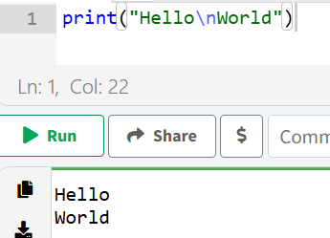
- “\t” inserts a tab. Example:
  - 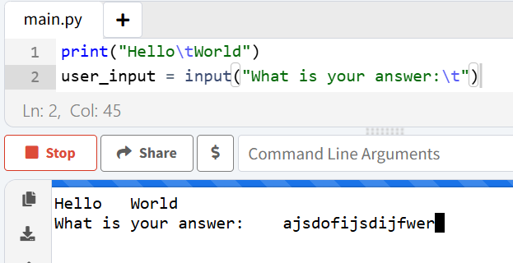
- Optionally, read more about Escape Codes here. Many are not often used, the ones above are most common.

More On The print() Function
- The print() function can take multiple arguments.These (positional) arguments are automatically converted to strings and printed out with a space separating them. Thus, different data types can be joined together without needing to cast.
  - 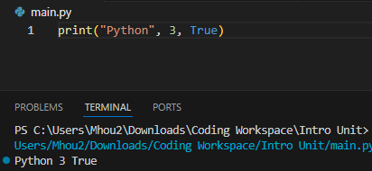
- To add variables easily, you can also do print(f”...{variable}...”) syntax. Variables are automatically converted to strings and can be put inside the code using the brackets.
  - 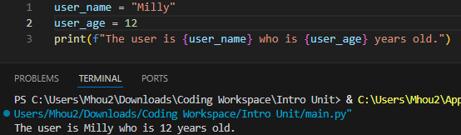

One more data type: Booleans
- Bools (short for booleans) are either True or False.
- They are also given mathematical values of 1 and 0 for True and False, respectively.
  - In the following example, the bools are has_extra_money and has_no_extra_money.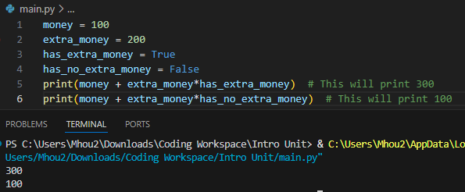

Basic Mathematics in Python
- a+b, a-b are addition and subtraction
- a*b is multiplication
- a**b is exponentiation
- a%b is modulo division (remainder of a divided by b)
- a/b is division (will always result in float)
  - Use a // b to get the integer truncation of any division (floor division). (always integer)
- 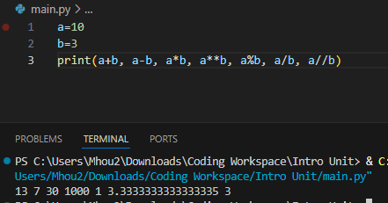

Conditional Expressions
- Condition statements return a boolean–True or False.
- Examples:
  - == -> equal to
  - != -> not equal to
  - < / > -> Less than / Greater than
  - <= / >= -> Less than or equal to / Greater than or equal to
  - 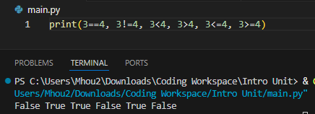
- Use and and or to have output of two statements
  - and is true if both statements are true
  - or is true if at least one statement is true.
  - 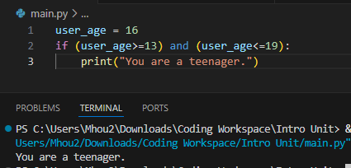

Conditional Statements
- These statements tell a program what to run based on different cases.
- if statements, elif statements (stands for else if), and else statements
- 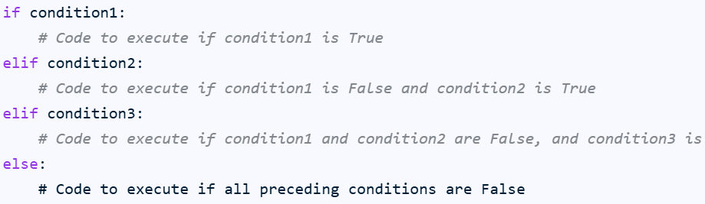
- Think about it this way; the first one that is true gets run. If all are false, then the else statement is run.
- 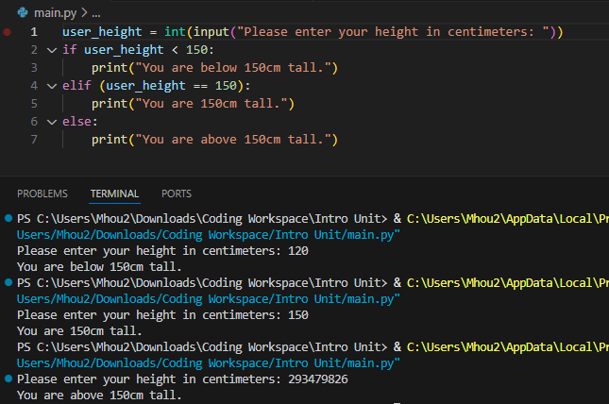
- If you need more conditions, consider researching match-case in python (not covered in class).

Conclusions
In class, we discussed some new information on print statements, special characters (escape codes), and conditionals. We started a Choose Your Own Adventure Project, a short, fun, easy text project. If your child / you want(s), they can present it next class :D
Please remember to encourage your children to participate actively and to stay focused in class!

